Center for Adaptive Riding
2800 Pioneer Dr., Reno, NV. 89509
Mailing Address: 59 Damonte Ranch Pkwy. B102, Reno, NV 89521
info@adaptiveriding.org ● 775-329-1839 ● www.AdaptiveRiding.org

2017 VOLUNTEER/STAFF ANNUAL INFORMATION

Enclosed is the annual information form and application. Please fill it out completely and return.

All lesson volunteers must attend our extensive Volunteer Training before working with our horses and riders. These trainings are scheduled about 3 times a year. Our intention is to give you lots of hands on experience with the horses and tack, as well as to practice the jobs that you will be doing during lessons and review safety and emergency procedures. A $15 donation is requested (not mandatory) to cover the cost of materials. Contact Amanda at ajudge@adaptiveriding.org for the next Volunteer Training. A mandatory annual Volunteer Refresher is scheduled in the Spring for Returning Volunteers.

If you ever have any questions, or anything you would like to discuss please do not hesitate to contact me.

Sincerely,

Amanda Judge,
Program Director, Instructor, Equine Manager

CAR Weather Policy

SAVE THIS PAGE FOR YOUR REFERENCE

Weather patterns can change quickly in Northern Nevada, and therefore a decision to cancel lessons will be made at least 1 hour before scheduled lesson time, and up to 24 hours in advance.

The following guidelines will be used to determine whether to cancel lessons at the Center for Adaptive Riding. It is the responsibility of the lesson instructor to determine whether the weather presents a hazard to the safety of lessons.

The following situations may cause the cancellation of lessons:

Heat
Temperatures above 95 degrees will be cause for cancellation of mounted lessons. The instructor may choose an un-mounted activity in lieu of cancellation.

Wind
High Wind Warnings, especially above 50 mph, including Blowing Dust Warnings and Blizzard Warnings.

Flash Flood Warnings
Threat of LOCAL flooding or a Flash Flood Warning issued by National Weather Service (NWS)

Thunderstorms
Thunderstorms are typically short-lived events, however lessons will be cancelled when thunder is audible, and lightening occurs within 5-10 seconds of thunder, or if NWS has issued a Severe Thunderstorm Warning.

Rain
Forecasted rainfall over .25 inches during a 2 hour period. Forecasts for 20-50% (slight chance of rain to chance of rain) chance of rain is not sufficient for cancellation.

Winter Storm Warnings
Snow, Ice, Sleet and Hail Warnings – Forecasted duration of storm is to be considered. Outside Temperatures below 45 degrees may be reason for cancellations.

The Center for Adaptive Riding considers safety its first priority. Riding Local weather and driving conditions may vary greatly, so it is the responsibility of parents, riders and volunteers to determine if their local conditions are too dangerous for their specific situation. Notify Center for Adaptive Riding at 775-329-1839 (text or call), or Amanda at 775-762-7118 (text or call) if you will not be coming for your scheduled lesson time. Please give as much notice as possible so that adjustments can be made accordingly.

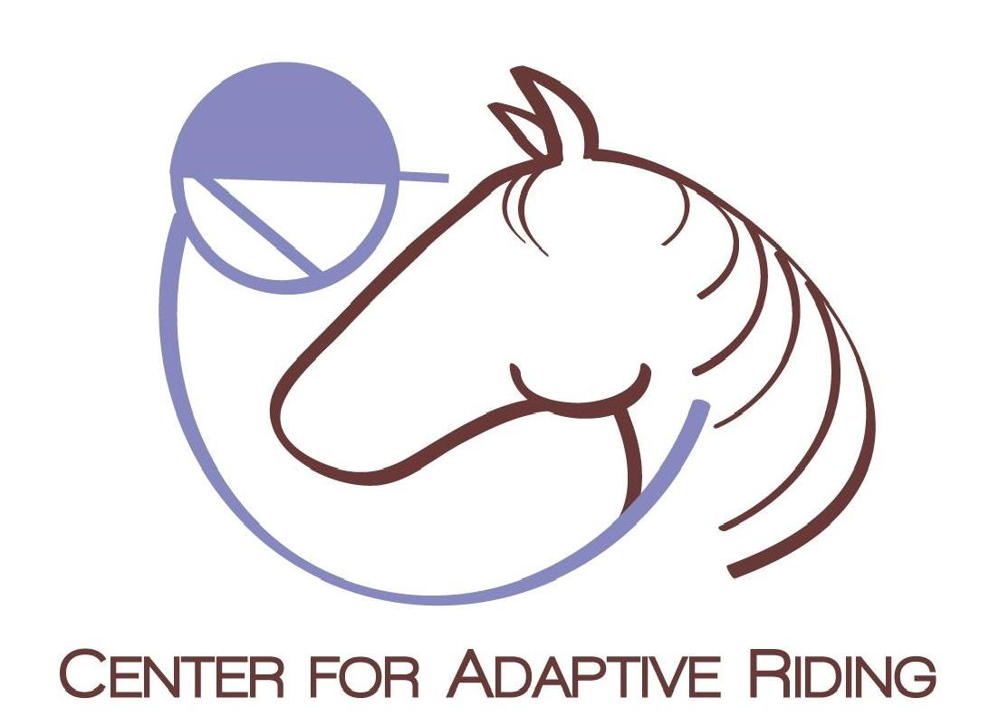 | Center for Adaptive Riding  2800 Pioneer Dr., Reno, NV. 89509  Mailing Address: 59 Damonte Ranch Pkwy. B102, Reno, NV 89521  info@adaptiveriding.org ● 775-329-1839 ● www.AdaptiveRiding.org

2017 Volunteer/Staff Information

Date: _________________________________ Date of Birth (m/d/y): _________________________

Name: ________________________________ Name you like to be called: ______________________

Address: _________________________________ City: ______________________ State: __________

Zip: __________ Home Phone: ______________________ Cell Phone: ________________________

E-mail: __________________________________

What is the best way to get in touch with you? Non-Emergency communications are done via email.

Home Phone Cell Phone Text E-mail Other ____________________________

Parent information (if under 18): _________________________________________________________

Your Occupation: _____________________________________________________________________

Workplace/School: ____________________________________________________________________

Do you have CPR or First Aid Training?  CPR expires______  First Aid expires ______

How did you learn about the Center for Adaptive Riding? _____________________________________

___________________________________________________________________________________

Please describe any experience you have working with people with special needs:

___________________________________________________________________________________

___________________________________________________________________________________

Please describe any experience you have working with horses: ________________________________
___________________________________________________________________________________

___________________________________________________________________________________

What would you like to get out of volunteering with the Center for Adaptive Riding? (i.e. learn more about horses, work with people with special needs, fundraising, marketing, etc.)
___________________________________________________________________________________

___________________________________________________________________________________

2017 Availability Form

Schedules will be updated throughout the year. This full application only needs to be submitted once, but a new availability form must be filled out prior to each session.

I want to volunteer:

______ once a week ______ twice a week

______ every other week ______ other: ________

Please specify number of days: _________________

How I want to help:

______ I will help in lessons ______ I can help on non-lesson days

______ other: ___________________________________________

Every attempt will be made to schedule volunteers for 3-4 hour shifts per day. If you would like to volunteer for more hours per day, OR if you would prefer volunteering for fewer hours, please make note of that below.

Lessons currently run Wednesday, Friday and Saturday.

Rank in order the days you can come out (1=best, 5=worst) | List your ideal times available (specific times or morning, mid-day, afternoon, evening)
Tuesday
Wednesday
Thursday
Friday
Saturday

I am not available (due to vacations, scheduling conflicts, etc): ______________________

____________________________________________________________________________

Can you walk for up to 60 minutes at a time? Y / N
Can you jog for short distances? Y / N
Given a chance to alternate sides, can you hold your arm above your shoulder height and support a modest weight? Y / N

Any other information we need to know for scheduling? __________________________________

___________________________________________________________________________________

___________________________________________________________________________________

Program Participation

The Center for Adaptive Riding not only needs volunteers for help in lessons, but also with operations, promotion and management. Please mark all that you are interested in, and/or that you wish to gain experience in.

______ Public Relations- Works to keep the Center for Adaptive Riding in the news by writing regular news articles and/or making media contacts.
______ Newsletter- Create quarterly newsletter, collect stories and photos to include.
______ Grant-Writing- Research and write grant/foundation/corporate requests.
______ Special Events- Assists in planning and implementing occasional special events
______ Board Member- Assist in directing the future
______ Budget & Finance
______ Photography/Video Production
______ Side Walker – assists rider in lesson
______ Horse Handler – lead and manage horses in lessons (for those wishing to do this, there is a test to evaluate ground work skills. If you do not have much experience with horses but would still like to pursue this, we offer training to help you reach this goal.)
______ Become a Professional Association of Therapeutic Horsmanship (PATH) instructor. (Our lead instructor is a certified mentor)
______ Horse Care - feed horses, clean paddocks, etc. on non-lesson days
______ Horse Management - help with training, conditioning and routine exercise of program horses. (Volunteers must be competent riders, and screened by the Equine Manager first.)
** Height __________ Weight:______________ (Required to ensure adequate match with horses)
Weight limit 190 lbs for riders (subject to negotiation based on horse and rider experience).
______ Maintenance- Provide general improvements including painting, cleaning, weeding, and other tasks as necessary
______ Other (We are always looking for new ideas to improve the program):

___________________________________________________________________________________

___________________________________________________________________________________

Confidentiality Agreement

I, ___________________________ promise that all information I might encounter at the Center for Adaptive Riding that pertains to students, staff, volunteers or other persons affiliated with Center for Adaptive Riding is strictly confidential and will not be discussed outside of the facility. This includes any personal interactions (even with riders or other volunteers outside of facility), social media, etc. Personal information not only pertains to events, diagnosis, interactions and/or activities, but also to images.

I, ____________________________________ have read, fully understand and agree to abide by Center for Adaptive Riding’s Confidentiality Agreement.

Signed: __________________________________________________ Date: _____________

Background Information

Have you ever been charged or convicted of a crime? Yes ___ No ___ If yes, please explain

____________________________________________________________________________

____________________________________________________________________________

I, ______________________________________ (volunteer/staff/student assistant), authorize the Center for Adaptive Riding to receive information from any law enforcement agency, including police departments and sheriff’s departments of this state or any other state or federal government, to the extent permitted by state and federal law, pertaining to any convictions I may have had for violations of state or federal criminal laws, including but not limited to convictions for crimes committed upon children.

I understand that such access is for the purpose of considering my application as an employee/volunteer/student assistant, and that I expressly DO NOT authorize the operating center, its directors, officers, employees, or other volunteers to disseminate this information in any way to any other individual, group, agency, organization or corporation.

Signature ____________________________________________________ Date ___________
(volunteer/student assistant/staff)
Parent Signature (if above is under 18 years of age) _____________________________ Date: __________

CURRENT DRIVER’S LICENSE Y ___ N ___ LICENSE/I.D. NUMBER ___________ STATE____

Photo Release

For valuable consideration given and which is hereby acknowledged, the undersigned hereby grants to the Center for Adaptive Riding permission to take still and moving photographs and films, including television pictures, of myself (name:_______________________________) and, consents and authorizes the Center for Adaptive Riding to use and reproduce the photographs, films and reproduction of pictures and to circulate and publicize the same by all means including, but not limited to, newspapers, television media, brochures, pamphlets, instructional material, books and clinical material. With respect to the foregoing matters, no inducements or promises have been made to me to release other than the intention of the Center for Adaptive Riding and its work.

Signature:____________________________________________ Date: _____________________

LIABILITY RELEASE FORM

WITNESS THIS AGREEMENT this ______ day of _________________, 20__, by and between the Center for Adaptive Riding, hereinafter referred to as "Farm," WHEREAS Farm is owned by the city of Reno, NV and operated by the Center for Adaptive Riding, located at 2800 Pioneer Dr., Reno, Nevada, 89509.,
and the individuals listed below, hereinafter referred to as "User”:

(List all individuals who will be visiting, participating and/or observing any and all programs at the Center for Adaptive Riding, including riders, legal guardians, family members, friends, etc.)

__________________________________________________
__________________________________________________
__________________________________________________
__________________________________________________
__________________________________________________

This is an agreement and covenant to release the city of Reno, NV., the Farm, ALL OF THEIR AGENTS, its board of directors, officers, employees, committees and volunteers from liability to the activity including, but not limited to horseback riding or other equine related activities, volunteering, observation, use of facilities or equipment, or any other participation in Farm programs.

I hereby agree to the following:

- In consideration for my being allowed to participate in equine related activities on Farm property, I, for myself and my heirs, assigns, and personal representatives, do hereby covenant not to sue and do hereby release The Farm and its Board of Directors, officers, employees, committees, and volunteers from ALL liability and waive any claim for damages arising from any cause whatsoever in that I assume all risks related to all equestrian activities referenced herein or in which I participate at or through The Farm, including property damage.
- I hereby covenant to indemnify and hold The Farm, and its Board of Directors, officers, employees, committees, and volunteers, or any other person harmless of damage or injury caused by my horse or myself due to my actions, my riding or the action of my horse and as part of any equestrian activity described herein.
- I understand that ALL physical equipment and facilities used with equestrian sports can contribute to an accident causing injury or death. I specifically assume full responsibility for such possibility.
- I understand that equestrian sports are extremely dangerous. There is a high probability that I may fall or otherwise have an accident that will injure me severely. I specifically assume full responsibility for such possibility.
- I understand that if a lawsuit is taken against the city of Reno, NV., The Farm, and its Board of Directors, officers, employees, committees, and volunteers and prevail in that lawsuit that I will pay all attorney fees, court costs, and other litigation costs incurred by The Farm, its Board of Directors, officers, employees, committees, and volunteers, and in defending such a lawsuit.

ACKNOWLEDGEMENT OF RISKS OF ENGAGING IN HORSEBACK RIDING
The undersigned acknowledges there are inherent risks associated with equine activities such as described below, and hereby expressly assumes all risks associated with participating in such activities. The inherent risks include, but are not limited to the propensity of equines to behave in ways such as, running, bucking, biting, kicking, shying, stumbling, rearing, falling or stepping on, that may result in an injury, harm or death to persons on or around them; the unpredictability of equine’s reaction to such things as sounds, sudden movement and unfamiliar objects, persons or other animals; certain hazards such as surface and subsurface conditions; collisions with other animals; the limited availability of emergency medical care; and the potential of a participant to act in a negligent manner that may contribute to injury to the participant or others, such as failing to maintain control over the animal or not acting within such participants ability.

User expressly releases Farm from any and all claims for personal injury or property damage, even if caused by negligence (if allowed by the laws of this State) by Farm or its representatives, agents or employer

EXPRESS ASSUMPTION OF RISK AND RESPONSIBILITY
I expressly assume the risk and legal responsibility for injury, loss, or damage to me or my property that result from participation in horseback riding or any other activity offered by The Farm. I agree to assume full responsibility for the risks identified herein as well as those risks not specifically identified. I expressly assume full responsibility for property damage and personal injury or accidents of every type and degree including, but not limited to, sprains, torn muscles and/or ligaments, fractured or broken bones, eye damage, cuts, scrapes, contusions, paralysis, neck and/or spinal injuries, shock, and death, and any resulting expenses.

WARNING

You are advised that there are inherent risks, including the risk of serious injury or death, while engaging in equine and equine related activities. By engaging in equine activities and in accordance with the terms of this agreement you hereby assume all risks of injury or death.

USER FURTHER AGREES TO HOLD FARM HARMLESS AND DEFEND IT FROM ANY AND ALL CLAIMS, DEMANDS, JUDGMENTS, ORDERS, OR LIABILITY WHATSOEVER ARISING AS A PROXIMATE RESULT OF ANY ACTIVITY OF USER, USERS AGENTS, EMPLOYEES AND REPRESENTATIVES ON PREMISES OF FARM.

Farm reserves the right to refuse access or use of any horse upon the premises that does not appear to Farm to be in good health, or is deemed dangerous or undesirable.

If any provision of this agreement is found to be unenforceable by a court of competent jurisdictions or by an arbitrator or panel of arbitrators, all other provisions shall remain in full force and effect.
I HAVE READ, UNDERSTOOD, AND ACCEPT THE TERMS AND CONDITIONS STATED HEREIN AND ACKNOWLEDGE THAT THIS AGREEMENT SHALL BE BINDING UPON ME (AND THE MINOR CHILD OR CHILDREN WHOM I HAVE CUSTODY) AND OUR HEIRS, ASSIGNS, PERSONAL REPRESENTATIVES AND ESTATES.

User:
Print rider/participant’s name: _____________________________________

Signed (if over 18): _____________________________________________

If under 18:
Print Parent/Guardian name:_______________________________________

Parent/Guardian Signature: ________________________________________

Date: ________________

Volunteer Expectations and Dismissal Policy

Volunteers can come to Center for Adaptive Riding without any previous experience with individuals with disabilities or horses. We are here to provide you with instruction which will help you develop skills while feeling safe and competent in the tasks you will be doing.
To ensure the safety of persons and horses at Center for Adaptive Riding all volunteers will need to meet certain requirements in order to participate in regular programming. These criteria include, but are not limited to:

- Ask questions so that you can follow and understand directions
- Confidently be able to respond to emergency situations that may arise in regard to all horses, riders, volunteers and staff present at the facility.
- Learn and consistently demonstrate safety practices as outlined in the Volunteer Manual
- Be consistent in attendance, arrive when scheduled, replace yourself or give plenty of notice if you cannot volunteer as scheduled.
- Able to lift 25 pounds
- Have the stamina and physical ability to walk and/or jog and maintain balance in lessons and around the barn.
  - If you do not meet this requirement, you must inform the instructor(s), lead volunteer, and/or Equine Manager.
  - If you do not meet this requirement, there are several activities and opportunities, both with lessons and outside of lessons, that you can readily participate in.

All staff, volunteers and guests involved in any activity of Center for Adaptive Riding are expected to:
  - Act in a professional manner
  - Be respectful and courteous towards participants (human and equine)
  - Follow the confidentiality policy
  - Dress appropriately (no revealing clothing, close toed shoes)
  - Refrain from use of obscene or vulgar language
  - Follow established safety procedures
  - Take direction from supervising personnel
  - Be on time
  - Give sufficient notification of cancellation (24 hours is preferred)
  - Not use alcohol or illegal drugs
  - Adhere to No Smoking Policy
  - Respect and care for facilities and properties belonging to CAR and landowners
  - Use appropriate interactions with riders/students, staff, volunteers, visitors at all times including but not limited to the following:
Touch
Not being alone with students
Content of conversation

If a volunteer’s actions are inappropriate, hurtful or create discomfort for any other participants, a formal warning will be issued from the instructor, board of directors, lead volunteer or equine manager. If the problem persists, the volunteer will be removed from any and all Center for Adaptive Riding activities and programs.
If the volunteer’s behavior results in gross negligence by the volunteer or the deliberate endangerment of a rider, a volunteer may be dismissed immediately..

I have read, reviewed and agree to the above guidelines: PRINT NAME: ___________________

Signature: _______________________________________________________ Date: __________

Authorization for Emergency Medical Treatment

Name: _________________________________ DOB: __________ Phone: _________________

Name of Person to Contact In Case of Emergency: ______________________________________

Relationship: ____________________________________________ Phone: _________________

Alternate Contact: ________________________________________ Phone: _________________

Physician’s Name: _______________________________________ Phone: _________________

Preferred Medical Facility: _________________________________________________________

Health Insurance Company: ________________________________ Policy # _________________

Health History

Please describe your current health status. Address fitness, cardiac, respiratory, bone or joint function, recent hospitalizations/surgeries, mental/emotional disorders, or lifestyle changes.

____________________________________________________________________________

____________________________________________________________________________

Allergies: ____________________________________________________________________

Medications: _________________________________________________________________

Recent medical tests: Last Tetanus Shot: _________ Tuberculosis Test + - Date: ________

(Please consult your physician or local health department if you are not up to date with these shots/tests)

Please explain any other health concerns that may affect your participation in any of Center for Adaptive Riding’s programs and activities:

___________________________________________________________________________________

___________________________________________________________________________________

I understand that the information provided above is accurate to the best of my knowledge. I know of no reason why I should not participate in the programs of the Center for Adaptive Riding.

Signed: ___________________________________________________ Date: _____________

Consent Plan
In the event emergency medical treatment is required due to illness or injury during the process of receiving services, or while assisting in the service of the Center for Adaptive Riding, I authorize the Center for Adaptive Riding to:
1. Secure and retain medical treatment and transportation, if needed.
2. Release records upon request to the authorized individual or agency involved in the medical
emergency treatment.

This authorization includes x-ray, surgery, hospitalization, medication and any treatment procedure deemed “life saving” by the physician. This provision will only be invoked if the contact person listed is unable to be reached.

Consent Signature: ______________________________________ Date: ________________

~~ OR ~~

Non-Consent Plan
I do not give my consent for emergency medical treatment/aid in the case of illness or injury during the process of receiving services, or while assisting in the service of the Center for Adaptive Riding.
□ Parent or legal guardian will remain on site at all times during equine assisted activities
□ In the event emergency treatment is required, I wish the following procedures to take place:

____________________________________________________________________________

____________________________________________________________________________

Non-Consent Signature: ____________________________________ Date: _______________

Please complete and return all pages to:

Center for Adaptive Riding
59 Damonte Ranch Pkwy. B102
Reno, NV. 89521
Or
ajudge@adaptiveriding.org

